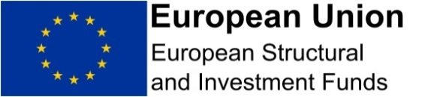

Name
Address 1
Address 2
Address 3
Address 4

Date: | xx August 2018
Dear xxxxx

INSERT POSITION
INSERT NAME OF PROJECT
INSERT NAME OF ORGANISATION / EMPLOYER
SUNDERLAND COMMUNITY LED LOCAL DEVELOPMENT PROGRAMME
PART-FUNDED BY THE EUROPEAN STRUCTURAL AND INVESTMENT FUNDS

I am writing to confirm your appointment to the above project in line with the activities described in the CLLD Full Application Form.

I can confirm that the project will run from 01 October 2018 to 30 September 2020 [INSERT CORRECT DATES]. You will spend an average of xxx hours per quarter / year on activities listed below:

- Xxxxxxxx
- Xxxxxxxx
- xxxxxxxx

In your post as [INSERT POSITION] you are currently employed full time at Grade XX, Spinal Point XX and your latest annual gross employment cost for the period from ………. to ………………. [INSERT PREVIOUS 12 MONTHS COSTS] was £XXXX including national insurance and superannuation costs.

The project is part-funded by the European Structural and Investment Fund (ESIF) Growth Programme 2014-2020 and you will be aware of the related requirements, in particular those of keeping timesheets and publicising the project in line with the ESIF and CLLD publicity guidance.

Your role in this project does not affect your terms and conditions of employment with [INSERT ORGANISATION NAME].

Yours sincerely,
Signed by appropriate Manager

