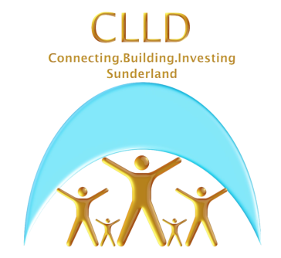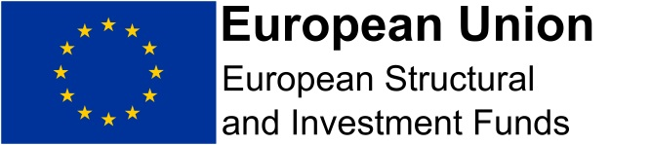

**STATE AID - DE MINIMIS DECLARATION**

In order to avoid public funding distorting competition within the European Common Market the European Commission regulates the levels of assistance which the public sector can provide to businesses or organisations (“the State Aid rules”).

It is proposed that the assistance to be provided to you by INSERT NAME OF ORGANISATION, as part of the INSERT PROJECT NAME project, will comply with the State Aid rules since it will be provided in accordance with the De Minimis aid exemption (as set out in Commission Regulation (EU) No 1407/2013, OJ L 352/1). Under this exemption, a single undertaking may receive up to the limit of €200,000 of De Minimis aid from the Member State within which it does business and which provides the aid over any period of three fiscal years.

Please complete the declaration below and arrange for a director or authorised signatory of your organisation / business to sign and return it.

|  |  |  |
| --- | --- | --- |
| **State Aid**  I understand that my organisation / business may only receive subsidised support to the value of 200,000 euros (approx. £174,000) under the de minimis block exemption, from all public agencies in any three year period.  Please list any de minimis aid below. This includes any grants, support or subsidised training that your business has received in the past three years. | | |
| **Description and provider** | **Date** | **Amount/£** |
|  |  |  |
|  |  |  |
|  |  |  |
|  |  |  |
|  |  |  |

It is also a requirement of State Aid rules that any business or organisation assisted with public funding is not in financial difficulty. Please read the statement below of Financial Good Standing and confirm that your organisation is not in financial difficulty by signing the declaration below.

**Statement of Financial Good Standing**

* I confirm that this organisation is not in financial difficulty and that neither the organisation nor its directors are in, or in expectation of, a state of bankruptcy, insolvency, compulsory winding up, administration, receivership, composition with creditors or any analogous state or subject to relevant proceedings or, (if the respondent organisation is a registered Provider of Social Housing), placed in supervision by the Regulator.
* I confirm that we have fulfilled our obligations relating to the payment of social security contributions and taxes.
* I confirm that our accounts have not been qualified by auditors in the last three (3) years or, if they have, details are attached, and that there have been no material post balance sheet events.

|  |
| --- |
| **Declaration** |
| I understand that this project is supported by the INSERT NAME OF PROJECT through the Sunderland Community Led Local Development Programme and declare that the details given on this form are true to the best of my knowledge. |

|  |  |
| --- | --- |
| **Organisation Name** |  |
| **Applicant Signature** |  |
| **Position** |  |
| **Date** |  |