

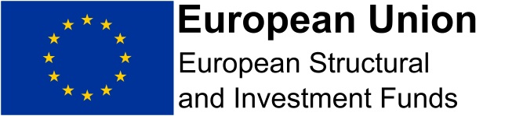

**Methodology for Quantifying Aid**

The methodology for quantifying aid will depend on the support provided to the project. It is likely that the aid will fall into one of the following categories:

|  |  |
| --- | --- |
| **Aid Provided** | **Method of Quantifying** |
| Grant offered to business | Actual amount of the grant provided |
| Consultancy support | Daily rate taken from the relevant consultancy website. For example, for IT consultancy <https://www.itjobswatch.co.uk/contract.aspx?q=consultancy&l=North+East&id=0>  A print of the page will be taken and kept on the project file for audit purposes.  The daily rate will be divided by 7.5 then will be multiplied by the number of hours of support. |
| Training | Actual cost of training, or in the case of a project procuring a training organisation to deliver to a high number of businesses, a quote from colleges or training providers will be used |
| Non-cash cost such as reduced rent | The difference between commercial market rate and what has actually be paid will be used as the amount of aid |

The amounts will be provided in pounds and the Europa website will be used to get the exchange rate for the day of support to convert it into Euros. Both amounts will be included in the letter confirming the value of support to the beneficiary. A print of the page will be put on the project file for audit purposes.

The amount of aid will then be recorded (in pounds and euros) on the beneficiary data spreadsheet and will show the amount of aid beside the individual business or organisation.