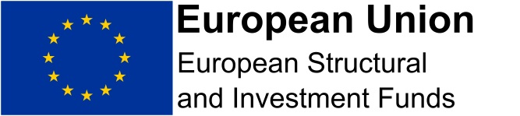
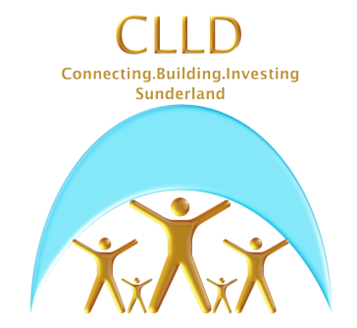

ADD ORGANISATION LETTERHEAD

Name
Address 1
Address 2
Address 3
Postcode
Date:

Dear

Project Name:

Sunderland Community Led Local Development (CLLD) Programme

Value of aid to Small and Medium sized Enterprises - De Minimis Aid as set out in Commission Regulation (EU) No 1407/2013, OJ L 352/1.

This letter is provided to confirm the value of the support recently provided to your business by the INSERT NAME OF PROJECT through the Sunderland CLLD Project, under the activity description shown below.

Therefore, the value of support that you have received from this project will count towards the De Minimis Aid ceiling of €200,000 per organisation / business (approx. £174,000) allowed in any 3 consecutive years. You will need to retain a record of this information if your organisation / business is either seeking additional public support or in receipt of additional public support within a 3-year rolling period.
His
Our records confirm the following value for all business support provided to your organisation / business through this project. This may include consultancy, training and all other activities carried out on your behalf.

Date | Description of support | No. of Hours | Cost (£/€)
 |  |  | £/€
 |  |  | £/€
Total |  |  | £/€

If you require further information in relation to this matter please contact………..

Yours sincerely

Name
Job Title

